ESTIMATING POPULATION SIZE

Populations are measured using various methods.

Capture–Recapture

• Suitable for animals that do not stay in one place.

• Scientists capture a small sample of the population and tag them in some
way.
e.g. With a leg band, paint spot or ear tag.

• The tagged animals are then released.

• Another sample is taken after a few days or weeks.

• The number of tagged individuals is recorded, as is the sample size.

• The following equation is used to calculate the population.

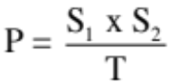

where P = population of the organism.
S₁ = size of the organisms caught, tagged and released.
S₂ = size of the second sample.
T = the number of tagged organisms in the second sample.

Example

Some ecologists were trying to estimate the population of fish in a lake.

They caught 50 fish and tagged them - this is S₁.

A few days later they caught 40 fish (S₂), of which four had tags (T),

The population would be:

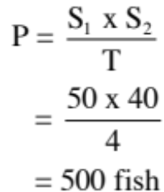
Quadrats

• A quadrat is a sampling area of a particular size and usually of a square shape.
• This method is particularly suitable for plants that do not move.
• An area is divided up into equalsize areas, called quadrats.
• A number of quadrats are chosen at random for sampling.

The following equation used to calculate the population of the organism.

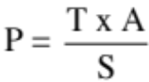

where P = the calculated population.
T = the total number of organisms counted in the 10 samples.
A = the total number of quadrats
S = the number of sample quadrats.

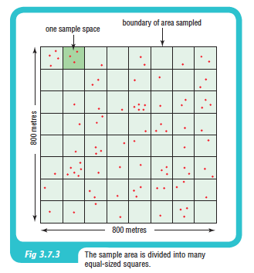
Example

Scientists want to count the trees in an area of 800 m x 800 m as shown in the diagram.

• The total area has been divided
up into 64 quadrats, each
100 m x 100 m.
• The scientists decide to use 10
quadrats, chosen randomly.
• Each quadrat is marked out.
• The number of trees is counted
in each quadrat.

Data - 16 trees (T) were counted
in the 10 sample areas.

The population estimate is:
